Jenkins Pipelines  
Lab VM Build Book

Brad Brown  
2020-05-02  
Version 1.0

# GitHub material

VM build instructions and script

<https://github.com/RedShiftSolutions/PipelineVMBuild.git>

Source code for Lab 4, including Jenkinsfile for the Lab 4 test and the configure.sh file

<https://github.com/RedShiftSolutions/JavaLoadTest.git>

# Build instructions

## Create base VM from Ubuntu LTS 18.04

### Download and validate ISO file

Available from <http://releases.ubuntu.com/18.04.4>

* This build used 18.04.4
* Filename: ubuntu-18.04.4-desktop-amd64.iso
* MD5 checksum: 764056499131c8fe22b27f6dbf52ab7d

### Create VM

This build uses VMWare, but in principle the hypervisor should not matter

VM build parameters

* Primary account: wasadmin
* Primary account password: wasadmin
* Cores: 2
* Disk: 20GB
* RAM: 4GB (Do not allocate less than 4GB RAM)

### Log in to VM

Log in to VM as user wasadmin, password wasadmin.

If prompted to perform an upgrade, do not do so; upgrades will be managed by the configuration script.

## Configure VM

### Update package catalogues

Open Terminal

Pin Terminal to toolbar (right-click on the Terminal icon in the toolbar and select “Add to favourites”)

Enter command

sudo apt update

I would wait a few minutes before proceeding to the next step; after doing apt update on a fresh VM, there may be background processes locking some of the package catalogue files for a while. If you proceed to the next step and get an error, wait a few minutes and try again

### Run configuration script

Run configuration script (supplied as configure.sh, and repeated below). We recommend copying the file into a script and running the script, rather than pasting the contents of the script into terminal.

# configure.sh

# Configuration script for Jenkins Pipelines course

# Install Vim

sudo apt install vim -y

# Install Git

sudo apt install git -y

# Install JDK

sudo apt install openjdk-8-jdk -y

# Install Maven

sudo apt install maven -y

# Install Jenkins

wget -q -O - https://pkg.jenkins.io/debian/jenkins.io.key | sudo apt-key add –

sudo apt-key adv --keyserver keyserver.ubuntu.com --recv-keys 9B7D32F2D50582E6

sudo sh -c 'echo deb http://pkg.jenkins.io/debian-stable binary/ > /etc/apt/sources.list.d/jenkins.list'

sudo add-apt-repository universe

sudo apt-get update

sudo apt-get install jenkins -y

# Jenkins agents require two new directories

sudo mkdir /var/lib/jenkinsAlpha

sudo chown jenkins:jenkins /var/lib/jenkinsAlpha

sudo mkdir /var/lib/jenkinsBravo

sudo chown jenkins:jenkins /var/lib/jenkinsBravo

## Jenkins initial configuration

Start Firefox

Navigate to <http://localhost:8080>

You will see an “Unlock Jenkins” screen:

In Terminal, cat the file /var/lib/jenkins/secrets/initialAdminPassword

Copy and paste the contents of the initialAdminPassword file into the Unlock Jenkins dialogue and click “Continue”. Do not save the “password” in Firefox.

At the “Customize Jenkins” pane, click “Install suggested plugins”. Wait while plugins are installed.

Create an admin user,

* Username: wasadmin
* Password: wasadmin
* Confirm password: wasadmin
* Full name: Admin
* E-mail address: admin@localhost.com

On the “Instance configuration” pane, click “Save and Finish”

On the “Jenkins is ready!” pane, click “Start using Jenkins”

## Configure environment variables

Select “**Manage Jenkins**”, then “**Configure System**”

In the “Global Properties”, select the “Environment variables” checkbox, then click “**Add**”

Enter a new environment variable

* Name: JAVA_HOME
* Value: /usr/lib/jvm/java-8-openjdk-amd64

Click “**Save**”

## Configure tools

Click “**Manage Jenkins**” then “**Global tool configuration**”

In the JDK section, click “**Add JDK**”,

Enter the name “Java8”,

And de-select “Install automatically”

Enter “/usr/lib/jvm/java-8-openjdk-amd64” as the value of JAVA_HOME

Do not click “Add JDK” again.

In the “Git” section,

Enter the value “/usr/bin/git” in the “Path to Git executable” field.

Click “**Save**”

## Install agent.jar

In Terminal,

cd /usr/share/jenkins

sudo wget http://localhost:8080/jnlpJars/agent.jar

ls

Verify that the file agent.jar is present.

## Configure nodes

Select “**Manage Jenkins**” then “**Manage Nodes and Clouds**”.

Select “**New Node**”

Enter “Alpha” in the Node name field

Select “Permanent Agent”

Select “**OK**”

On the subsequent pane, enter

* Remote root directory: “/var/lib/jenkinsAlpha”
* Labels: “Linux”
* Launch method: “Launch agent via execution of command on the master”
* Launch command (one line):   
  java -DJENKINS_HOME=/var/lib/jenkinsAlpha -jar /usr/share/jenkins/agent.jar

Select “**Save**”

The Alpha node will show in the node list; it may show an error briefly as it takes longer to start than to refresh the web page, but the error should clear if you refresh the page.

Repeat the process to add a “Bravo” node, entering “Bravo” instead of “Alpha” in the instructions.

# Test configuration

## Create a test job

From Jenkins Home,

Select “**New Item**”

Enter item name: testConfiguration

Select “**Pipeline**” job type

Select “**OK**”

## Enter code for test job

We will test using code from the solution for Lab 4; this code exercises all nodes.

Select the “Pipeline” tab in the job configuration and enter the code in the “Script” text box. The code is supplied in a file “testConfiguration.groovy”, repeated below.

def builds = [:]

node('Master') {

stage('Compile') {

git 'https://github.com/RedShiftSolutions/JavaLoadTest'

sh 'mvn -B package'

stash includes: 'target/*.jar', name: 'Jars'

}

}

def testApp(int magic) {

def retVal = 'OK'

try {

sh "java -cp target/widget-1.0.jar com.acme.App ${magic} > results_${magic}.out"

} catch (e) {

retVal = 'Fail'

}

return retVal

}

def mkBuild(n) {

def i = n

return {

node('Linux') {

unstash 'Jars'

if (testApp(i) != "OK") {

// "Save" test data

archive includes: "results_${i}.out"

}

}

}

}

stage('EnqueueBuilds') {

// Try magic numbers 1 - 50

for (i=1; i<=50; i++) {

builds["Build$i"] = mkBuild(i)

}

}

stage('RunTests') {

parallel builds

}

Click “**Save**”

Click “**Build now**” to run the job. The job should take several tens of seconds to run, and the ball beside the build number (“#1”) should turn blue when the job finishes.

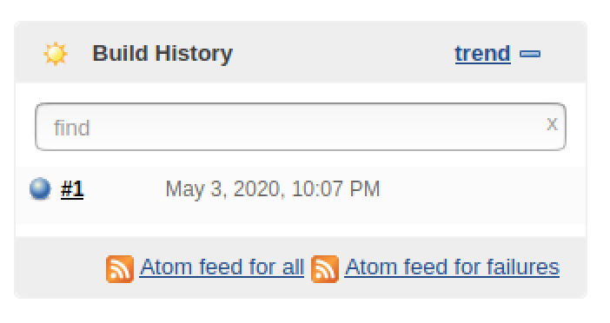

Refresh the page. You should see something like this:

